**UHCL Library**



Online Library System Software Requirements Specification

# Version 1.2

**Revision History**

|  |  |  |  |
| --- | --- | --- | --- |
| **Date** | **Version** | **Description** | **Author** |
| 16/Oct/2006 | 1.0 | Software Requirements Specification Document Initial Release. | Author |
| 01/Dec/2006 | 1.1 | Software Requirements Specification Document Release 1.1. | Author |
| 03/Dec/2006 | 1.2 | Software Requirements Specification Document Final Release. | Author |

**Table of Contents**

1. Introduction 5
   1. Purpose 5
   2. Scope 5
   3. Definitions, Acronyms and Abbreviations 6
   4. References 6
   5. Overview 6
2. Overall Description 6
3. Specific Requirements 8
   1. Functionality 8
      1. Logon Capabilities 8
      2. Mobile Devices 8
      3. Alerts 8
   2. Usability 8
   3. Reliability 8
      1. Availability 9
      2. Mean Time Between Failures (MTBF) 9
      3. Mean Time to Repair (MTTR) 9
      4. Accuracy 9
      5. Maximum Bugs or Defect Rate 9
      6. Access Reliability 9
   4. Performance 9
      1. Response Time 9
      2. Administrator/Librarian Response 9
      3. Throughput 9
      4. Capacity 9
      5. Resource Utilization 9
   5. Supportability 9
      1. Internet Protocols 9
      2. Information Security Requirement 9
      3. Billing System Data Compatibility 10
      4. Maintenance 10
      5. Standards 10
   6. Design Constraints 10
      1. Software Language Used 10
      2. Development Tools 10
      3. Class Libraries 10
   7. On-line User Documentation and Help System Requirements 10
   8. Purchased Components 10
   9. Interfaces 11
      1. User Interfaces 11
      2. Hardware Interfaces 13
      3. Software Interfaces 13
      4. Communications Interfaces 13
   10. Licensing Requirements 13
   11. Legal, Copyright, and Other Notices 13
   12. Applicable Standards 13
4. Supporting Information 13

# Software Requirements Specification

## Introduction

Borrowing books, returning books or viewing the available books at the Library of the local University is currently done manually where in the student has to go to the Library and check the available books at the Library. Students check the list of books available and borrow the books if the book is a borrow book otherwise it is of waste for the student to come to the library to come to check for the books if the student doesn’t get the book. Then the librarian checks the student id and allows the member to check out the book and the librarian then updates the member database and also the books database. This takes at least one to two hours if the member is available at the near by place otherwise it may take more time.

We have decided to investigate the use of an Online Library Management System. This system would be used by members who may be students or professors of that University to check the availability of the books and borrow the books, and by the librarian to update the databases. The purpose of this document is to analyze and elaborate on the high-level needs and features of the *Online Library System***.** It focuses on the capabilities and facilities provided by a Library. The details of what all are the needs of the *Online Library System* and if it fulfils these needs are detailed in the use-case and supplementary specifications.

#### Purpose

The purpose of **Software Requirements Specification (SRS)** document is to describe the external behavior of the Online Library System. Requirements Specification defines and describes the operations, interfaces, performance, and quality assurance requirements of the Online Library System. The document also describes the nonfunctional requirements such as the user interfaces. It also describes the design constraints that are to be considered when the system is to be designed, and other factors necessary to provide a complete and comprehensive description of the requirements for the software. The Software Requirements Specification (**SRS**) captures the complete software requirements for the system, or a portion of the system. Requirements described in this document are derived from the Vision Document prepared for the Online Library System.

#### Scope

The Software Requirements Specification captures all the requirements in a single document. The *Online Library System* that is to be developed provides the members of the Library and employees of the library with books information, online blocking of books and many other facilities. The Online Library System is supposed to have the following features.

* + - The product provides the members with online blocking of books capabilities and the Online Library System is up and running all day.
    - The system provides logon facility to the users.
    - The system provides the members with the option to check their account and/or change their options like password of the account whenever needed all through the day during the library hours.
    - The system allows the members to block the books 24 hours a day and all the through the semester.
    - The system lets the library staff to check which all members have blocked the books and whether they can borrow any more books or not.
    - The system allows the Librarian to create the books catalog, add/delete books and maintain the books catalog.
    - The system updates the billing system as and when the member borrows or returns a book.
    - The book catalog is automated and the decision of offering the book based on the category of the book is automatically decided.
    - We also have an order department, which manages to add or remove a book from the Library.

The features that are described in this document are used in the future phases of the software development cycle. The features described here meet the needs of all the users. The success criteria for the system is based in the level up to which the features described in this document are implemented in the system.

#### Definitions, Acronyms and Abbreviations

* + - UHCL – University of Houston-Clearlake.
    - Provided wherever necessary in the document.
    - PIN – Personal Identification Number

#### References

The *SRS document* uses the following documents as references:

* + 1. ***UHCL Information Security Requirements:*** To provide security to the system based on the current security system currently used by UHCL.
    2. ***The Billing System:*** To provide the interface between the system being developed and the billing system currently in use by UHCL to update the member account due as and when they borrow and return the books.

#### Overview

The SRS will provide a detailed description of the Online Library System. This document will provide the outline of the requirements, overview of the characteristics and constraints of the system.

* + 1. ***Section 2:*** This section of the SRS will provide the general factors that affect the product and its requirements. It provides the background for those requirements. The items such as product perspective, product function, user characteristics, constraints, assumptions and dependencies and requirements subsets are described in this section.
    2. ***Section 3:*** This section of SRS contains all the software requirements mentioned in section 2 in detail sufficient enough to enable designers to design the system to satisfy the requirements and testers to test if the system satisfies those requirements.

## Overall Description

#### Product Perspective

The Online Library System is a package to be used by Libraries to improve the efficiency of Librarians, Library employees and Users. The Online Library System to be developed benefits greatly the members and the Librarian of University of Houston-Clearlake. The system provides books catalog and information to members and helps them decide on the books to borrow from the library. The Librarian can keep the books catalog updated all the time so that the members (students and the professors) get the updated information all the time.

The complete overview of the system is as shown in the overview diagram below:

The product to be developed has interactions with the users: Librarian, Members who are the students and professors of the UHCL.

The product has to interact with other systems like: Internet, Billing System and the UHCL Information Security System.

#### Librarian

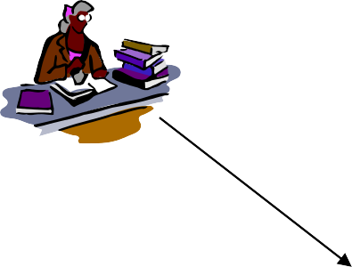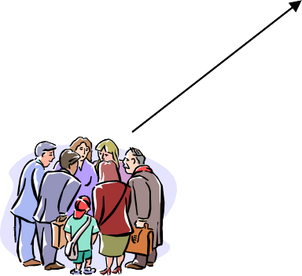

**Billing System**

#### The Proposed Online Library Management System

**UHCL Information Security System**

#### Users

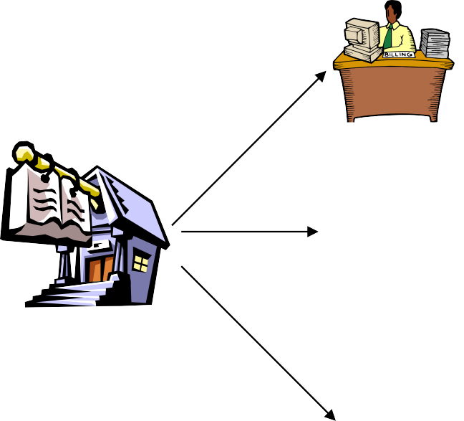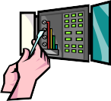

***Overview of the proposed system***

**Internet**

* **Product Functions**

The Online Library System provides online real time information about the books available in the Library and the user information. The Product functions are more or less the same as described in the product perspective. The functions of the system include the system providing different type of services based on the type of users [Member/Librarian].

* + The member should be provided with the updated information about the books catalog.
  + Provisions for the members to borrow the books they want, if all the other required rules hold good.
  + The member is given a provision to check his account information and change the account information any time in the given valid period.
  + The members are provided with the books available roster and allowed to choose the books, which they want to use in the coming up days.
  + The librarian can get the information about the members who have borrowed or returned the books.
  + The librarian is provided with interfaces to add/delete the books available in the book catalog.
  + The members when complete the book borrowing or returning process, the due to be paid by the member must be calculated and the information about the member and the due amount is sent to the university billing system.
  + The system uses the University information security requirements to provide the login facility to the users.

### User characteristics

The users of the system are members, librarian of the university and the administrators who maintain the system. The members and the librarian are assumed to have basic knowledge of the computers and

Internet browsing. The administrators of the system to have more knowledge of the internals of the system and is able to rectify the small problems that may arise due to disk crashes, power failures and other catastrophes to maintain the system. The proper user interface, users manual, online help and the guide to install and maintain the system must be sufficient to educate the users on how to use the system without any problems.

### Constraints

* + The information of all the users must be stored in a database that is accessible by the Online Library System.
  + The university information security system must be compatible with the Internet applications.
  + The Online Library System is connected to the university computer and is running all 24 hours a day.
  + The users access the Online Library System from any computer that has Internet browsing capabilities and an Internet connection.
  + The billing system is connected to the Online Library System and the database used by the billing system must be compatible with the interface of the Online Library System.
  + The users must have their correct usernames and passwords to enter into the Online Library System.

### Assumptions and dependencies

* + The users have sufficient knowledge of computers.
  + The University computer should have Internet connection and Internet server capabilities.
  + The users know the English language, as the user interface will be provided in English
  + The product can access the university student database

## Specific Requirements

This section describes in detail all the functional requirements.

#### Functionality

* + 1. *Logon Capabilities*

The system shall provide the users with logon capabilities.

* + 1. *Mobile Devices*

The Online Library System is also supported on mobile devices such as cell phones.

* + 1. *Alerts*

The system can alert the Librarian or the administrator in case of any problems.

#### Usability

* + - The system shall allow the users to access the system from the Internet using HTML or it’s derivative technologies. The system uses a web browser as an interface.
    - Since all users are familiar with the general usage of browsers, no specific training is required.
    - The system is user friendly and self-explanatory.

#### Reliability

The system has to be very reliable due to the importance of data and the damages incorrect or incomplete data can do.

* + 1. *Availability*

The system is available 100% for the user and is used 24 hrs a day and 365 days a year. The system shall be operational 24 hours a day and 7 days a week.

* + 1. *Mean Time Between Failures (MTBF)*

The system will be developed in such a way that it ***may*** fail once in a year.

* + 1. *Mean Time to Repair (MTTR)*

Even if the system fails, the system will be recovered back up within an hour or less.

* + 1. *Accuracy*

The accuracy of the system is limited by the accuracy of the speed at which the employees of the library and users of the library use the system.

* + 1. *Maximum Bugs or Defect Rate*

Not specified.

* + 1. *Access Reliability*

The system shall provide 100% access reliability.

#### Performance

* + 1. *Response Time*

The Splash Page or Information page should be able to be downloaded within a minute using a 56K modem. The information is refreshed every two minutes. The access time for a mobile device should be less than a minute. The system shall respond to the member in not less than two seconds from the time of the request submittal. The system shall be allowed to take more time when doing large processing jobs.

* + 1. *Administrator/Librarian Response*

The system shall take as less time as possible to provide service to the administrator or the librarian.

* + 1. *Throughput*

The number of transactions is directly dependent on the number of users, the users may be the Librarian, employees of the Library and also the people who use the Library for checking-out books, returning books and checking online library account.

* + 1. *Capacity*

The system is capable of handling 250 users at a time.

* + 1. *Resource Utilization*

The resources are modified according the user requirements and also according to the books requested by the users.

#### Supportability

The system designers shall take in to considerations the following supportability and technical limitations.

* + 1. *Internet Protocols*

The system shall be comply with the TCP/IP protocol standards and shall be designed accordingly.

* + 1. *Information Security Requirement*

The system shall support the UHCL information security requirements and use the same standard as the UHCL information security requirements.

* + 1. *Billing System Data Compatibility*

The member balance amount that will be calculated and sent to the billing system shall be compatible with the data types and design constraints of the billing system.

* + 1. *Maintenance*

The maintenance of the system shall be done as per the maintenance contract.

* + 1. *Standards*

The coding standards and naming conventions will be as per the American standards.

#### Design Constraints

* + 1. *Software Language Used*

The languages that shall be used for coding the Online Library System are Active Server Pages (ASP), Java Servlets, Java Server Pages (JSP), HTML, JavaScript, and VBScript. For working on the coding phase of the Online Library System, the Internet Information Services (IIS) Server needs to be installed.

* + 1. *Development Tools*

Will make use of the available Java Development Tool kits for working with Java Beans and Java Server Pages. Also will make use of the online references available for developing programs in ASP, HTML and the two scripting languages, JavaScript and VBScript.

* + 1. *Class Libraries*

Will make use of the existing Java libraries available for JSP and Servlets. Also we need to develop some new libraries for the web-based application. Also will develop new programs using ASP and scripting languages.

#### On-line User Documentation and Help System Requirements

Online help is provided for each of the feature available with the Online Library System. All the applications provide an on-line help system to assist the user. The nature of these systems is unique to application development as they combine aspects of programming (hyperlinks, etc) with aspects of technical writing (organization, presentation). Online help is provided for each and every feature provided by the system.

The User Manual describes the use of the system to Librarian and Employees. It describes the use of the system on mobile systems. The user manual should be available as a hard copy and also as online help.

An installation document will be provided that includes the installation instructions and configuration guidelines, which is important to a full solution offering. Also, a Read Me file is typically included as a standard component. The Read Me includes a “What’s New With This Release” section, and a discussion of compatibility issues with earlier releases. Most users also appreciate documentation defining any known bugs and workarounds in the Read Me file.

Since the installation of Online Library System is a complex process, our experts will do it. So an installation Guide will not be provided to the user.

#### Purchased Components

The System Administrator will need to purchase the license for IIS Server. Mostly it is available with Windows Environment. So the system need not purchase any licensing products.

#### Interfaces

* + 1. *User Interfaces*

Will make use of the existing Web Browsers such as Microsoft Internet Explorer or Netscape. The user- interface of the system shall be designed as shown in the user-interface prototypes.

##### Logon Screen Prototype:

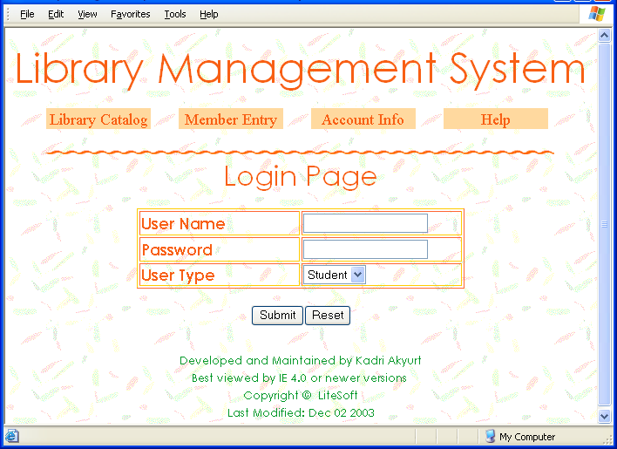

***Home Page Of UHCL Library Prototype:***

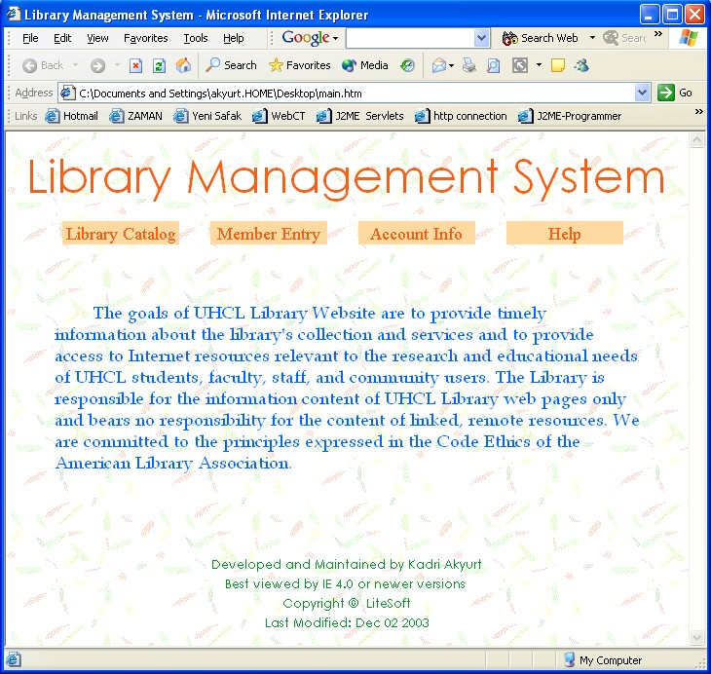

##### Member Registration Screen:

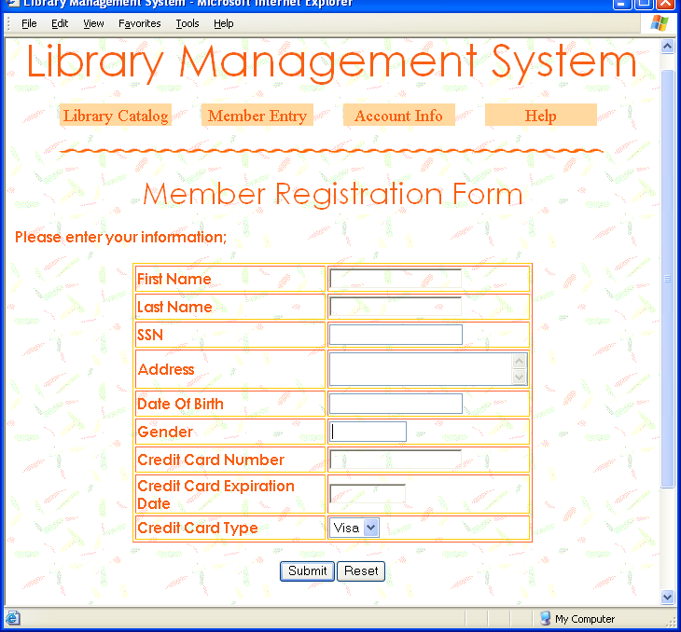

***Member Information once Logged in:***

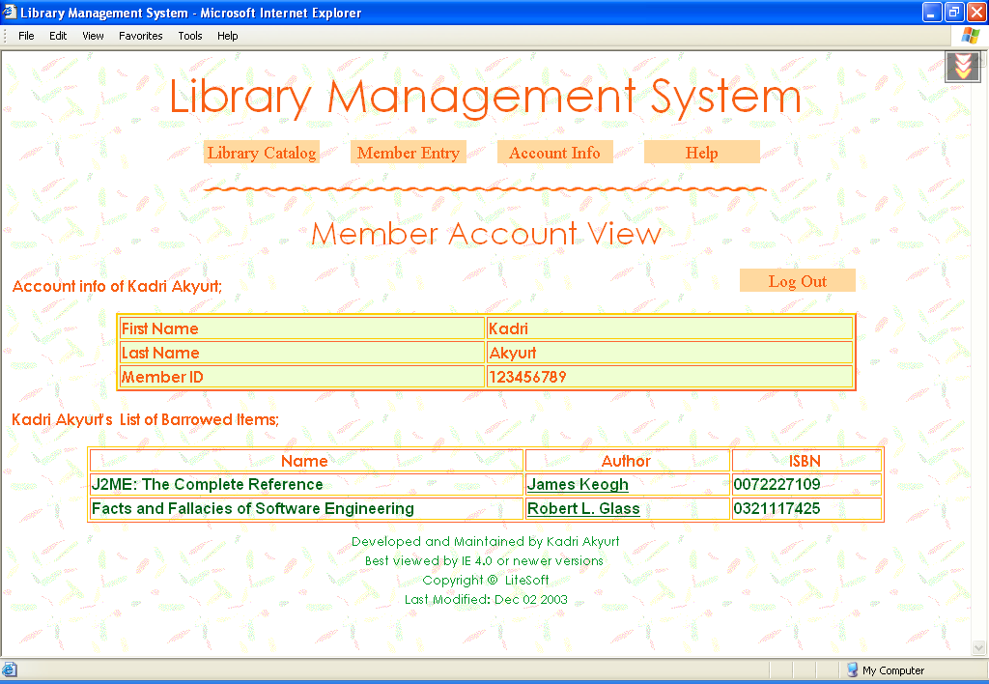

##### Main Search Page of Library Catalog:

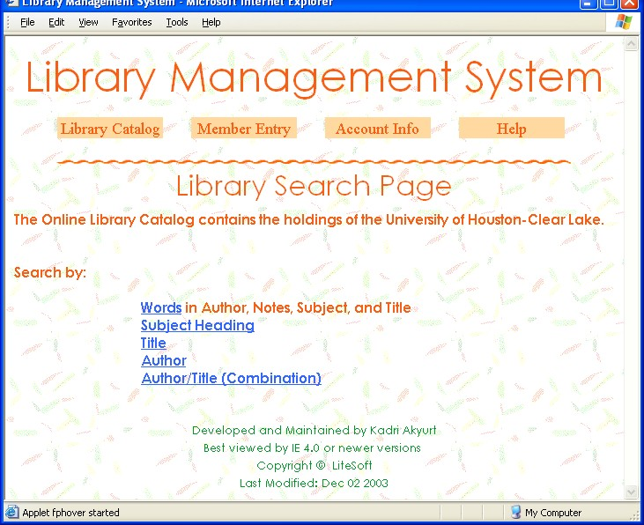

* + 1. *Hardware Interfaces*

The existing Local Area Network (LAN) will be used for collecting data from the users and also for updating the Library Catalogue.

* + 1. *Software Interfaces*

A firewall will be used with the server to prevent unauthorized access to the system.

* + 1. *Communications Interfaces*

The Online Library System will be connected to the World Wide Web.

#### Licensing Requirements

The usage is restricted to only University of Houston-Clearlake Library who is purchasing the Online Library System from Library InfoSys and signs the maintenance contract.

#### Legal, Copyright, and Other Notices

Online Library System is a trademark of Library InfoSys and cannot be used without its consent.

#### Applicable Standards

The ISO/IEC 6592 guidelines for the documentation of computer based application systems will be followed.

## Supporting Information

The use-case storyboards or the user-interface prototypes are not available. The appendices are not to be considered as part of the requirements.